**SCIGEN 101/101G**

**THE UNIVERSITY OF AUCKLAND**

**SEMESTER TWO, 2024**

**Campus: City**

**Time Allowed: 2 hours and 30 min additional time**

**NOTE:** Answer All questions from Section A Answer All questions from Section B Answer All questions from Section C Answer All questions from Section D

Section A consists of 10 MULTI-CHOICE/ MULTIPLE RESPONSE QUESTIONS, AND 1 LONG ANSWER QUESTION

Section B consists of 8 MULTI-CHOICE/ MULTIPLE RESPONSE QUESTIONS, AND 1 LONG ANSWER QUESTION

Section C consists of 2 SHORT ANSWER QUESTIONS, AND 1 LONG ANSWER QUESTION

Section D consists of 5 MULTI-CHOICE/ TRUE OR FALSE, MULTIPLE RESPONSE, DRAG AND DROP QUESTIONS, AND 1 LONG ANSWER QUESTION

This Exam is worth 50% of your final grade

 **By submitting this assessment, I agree to the following declaration:**

As a member of the University’s student body, I will complete this assessment with academic integrity and in a fair, honest, responsible, and trustworthy manner. This means that:

 I will not seek out any unauthorised help in completing this assessment. Unauthorised help includes, but is not limited to, asking another person, friend, family member, third party including artificial intelligence, tutorial, search function or answer service, whether in person or online.

 I will not discuss or share the content of the assessment with anyone else in any form during the assessment period, including but not limited to, using a messaging service,

communication channel or discussion forum, Canvas, Piazza, Chegg, third party website, Facebook, X (formally Twitter), Discord, social media, or any other channel.

 I will not use translation tools/services to translate assessment material or my answers, with the exception of keywords and short phrases translated in a manner similar to looking up a dictionary definition.

 I will not reproduce and/or share the content of this assessment in any domain or in any form where it may be accessed by a third party.

 I will not share my answers or thoughts regarding this assessment in any domain or in any form within the assessment period.

 I am aware the University of Auckland may use Turnitin or any other plagiarism detecting methods to check my content.

 I declare that this assessment is my own work, except where acknowledged appropriately (e.g., use of referencing).

 I declare that this work has not been submitted for academic credit in this or another University of Auckland course, or elsewhere.

I understand the University expects all students to complete coursework with integrity and honesty. I promise to complete all online assessment with the same academic integrity standards and values.

Any identified form of poor academic practice or academic misconduct will be followed up and may result in disciplinary action.

**I confirm that by completing this assessment I agree to the above statements in full.**

**Section A questions were written by Marie McEntee and you should draw from her lectures and studios in week 1-4 to answer this section.**

**Section A is worth a total of 15 marks. Answer ALL questions in this section.**

**There are TEN multi-choice / multiple response questions worth 1 mark each and cover:**

 **Communication processes and models;**

 **Identifying characteristics of complex problems; ** **Behaviour change approaches;**

 **Managing environmental problems.**

**There is also ONE long answer question worth five marks relating to two-way approaches to communication. You are allowed to use bullet points to answer this question. Your answer should not exceed 300 words.**

1. Which of the following would be the MOST likely problem to be regarded as a complex societal problem

**Select one alternative:**

 Developing a treatment for pancreatic cancer

 Removing rats from a small island with no people

 Finding a biological treatment to prevent kauri dieback

 Closing public forest tracks to prevent the spread of kauri dieback

Maximum marks: 1

1. Using the broadest definition of social actors, who would NOT be regarded as an ‘actor’ or ‘actor group’ in the Painted Apple Moth eradication.

**Select one alternative:**

 Programme managers from the Ministry of Agriculture and Forestry

 School children of Great Barrier Island

 West Auckland residents

 Painted apple moth caterpillars

Maximum marks: 1

1. Which of the following models would be regarded as a fully bottom-up model of communication?

**Select one alternative:**

 Transmission model

 Deficit model

 Dialogic model

 Receiver-oriented model

Maximum marks: 1

1. Which is NOT a component of the basic SMCR model of communication?

**Select one alternative:**

 Message

 Signal

 Receiver

 Channel

Maximum marks: 1

1. In an environmental context, which type of problem requires relationship-building with communities as a central feature of any engagement to address the problem?

**Select one alternative:**

 Complex problem

 Simple problem

 Chaotic Problem

 Complicated problem

Maximum marks: 1

1. Which would be the LEAST effective approach to encourage people’s use of kauri dieback boot cleaning stations?

**Select one alternative:**

 Communication prompts such as stickers for regular visitors cars

 Information brochures

 Kauri dieback ambassador at cleaning stations

 Social-norming techniques

Maximum marks: 1

1. Which communication model would be the MOST appropriate to use if you wished to co-design a project with affected community members?

**Select one alternative:**

 Deficit model communication

 Transmission model of communication

 Dialogic model of communication

 Receiver-oriented model of communication

Maximum marks: 1

1. Which of the following behaviours or attitudes in an individual would likely indicate LOW psychological distancing towards kauri dieback management approaches?

**Select one alternative:**

 High trust in authority

 Poor use of boot cleaning stations

 Human-centred (anthropocentric) environmental worldview

 Weak compliance of forest track signs

Maximum marks: 1

1. Which of the following social actors did NOT provide local knowledge in the Toitū te Ngahere project: Art in Schools for Forest Health?

**Select one alternative:**

 The school children

 University of Auckland researchers

 Mana whenua

 The school principals

Maximum marks: 1

1. Which of the following TWO alternatives are characteristics of a wicked or complex environmental problem?

**Select TWO alternatives:**

 Have multiple stakeholders

 Can only be tamed not solved

 Can be solved through trial and error approaches ('normal' science)

 Can be solved by single disciplinary knowledge experts

Maximum marks: 1

1. Use ONE or more environmental cases taught in weeks 3 and 4 of the course to describe what a dialogical approach to communication might look like.

**Fill in your answer here. You may use bullet points (do not exceed 300 words)**

|  |
| --- |
| Format  Σ  |
|  |
| Words: 0 |

Maximum marks: 5

**Section B questions were written by Nicolette Rattenbury and you should draw from her lectures in weeks 5 and 7 to answer this section.**

**Section B is worth a total of 15 marks. Answer ALL questions in this section.**

**There are EIGHT multi-choice / multiple response questions worth either 1 or 2 marks each and cover:**

 **Mathematical modelling**

 **Mathematical relationships**

**There is also ONE long answer question worth five marks relating to the modelling cycle. You are allowed to use bullet points to answer this question. Your answer should not exceed 300 words.**

1. Which of the following functions would best represent attendance numbers at a swimming pool over a year?

**Select one alternative:**

 Inversely proportional

 Exponential growth

 Linear

 Cubic

 Quadratic

 Periodic

 Exponential decay

Maximum marks: 1

1. The company operating the pool decides to model the expected number of visitors over the course of a year. Which of the following would be a valid assumption?

**Select one alternative:**

 Swimmers spend an hour on average each time they visit.

 The attendance is the same on the same day each week.

 300 people visit the pool each week.

 The pool is 33m long.

Maximum marks: 1

1. Which function is being described here? When x is large and negative, the function is large and positive. As x increases, the function decreases, before stopping and then going back up again. **Select one alternative:**

 Cubic

 Exponential growth

 Linear

 Inversely proportional

 Quadratic

 Exponential decay

 Periodic

Maximum marks: 1

1. A student wants to 3D print a figurine. Which of the following functions would best represent how much filament is used in relation to the height of the figurine?

**Select one alternative:**

 Linear

 Exponential decay

 Inversely proportional

 Cubic

 Periodic

 Exponential growth

 Quadratic

Maximum marks: 1

1. A flight company is modelling how much fuel their plane will need to safely fly from Auckland to Sydney. Which of the following functions would best represent how much fuel is used per kilometre flown?

**Select one alternative:**

 Exponential growth

 Cubic

 Linear

 Periodic

 Inversely proportional

 Exponential decay

 Quadratic

Maximum marks: 1

1. A flight company is modelling how much fuel their plane will need to safely fly from Auckland to Sydney. Which of the following would be factors that need to be taken into consideration when doing the modelling? Choose all that apply. (2 marks)

**Select one or more alternatives:**

 How many passengers are onboard.

 The distance from Auckland to Sydney.

 What day of the week it is.

 How far away from the airport the pilot lives.

 How much cargo is being carried.

 How windy it is predicted to be.

Maximum marks: 2

1. Unfortunately a student in one of the halls contracts a very contagious disease. Which of the following functions would best represent how quickly the disease will spread through the halls? **Select one alternative:**

 Linear

 Exponential growth

 Periodic

 Exponential decay

 Quadratic

 Inversely proportional

 Cubic

Maximum marks: 1

1. The students decide to model how quickly the disease is likely to spread. Which of the following would be factors that need to be taken into consideration when doing the modelling. Choose all that apply. (2 marks)

**Select one or more alternatives:**

 Whether there is a shared dining room for the whole hall, or self cooking in smaller pods.

 How often students read a book.

 How often students play ping-pong.

 How oftens students brush their teeth.

 How many students live in the halls.

 How many students wear masks.

Maximum marks: 2

1. There has been a huge storm and a lot of debris has washed up on a local beach.You want to organise a community clean up to tidy of the beach.Use the modelling cycle to help you calculate the number of volunteers required to get the clean up done in a day. List each stage of the

modelling cycle and explain what you should be doing ateach stage, giving examples where relevant.

You are allowed to use bullet points to answer this question. Your answer should not exceed 300 words.

**Fill in your answer here**

|  |
| --- |
|  |

Maximum marks: 5

**Section C relates to content taught by Jacquie Bay in Week 8:**

Science Communication and the '5+A-Day' case study.

**Section C is worth a total of 10 marks.**

 Answer ALL questions in this section  Question 22 is worth 2 marks

 Questions 23 and 24 are worth 4 marks each

You should write using sentences and paragraphs. You may include bullet points in your answers.

1. The images below have been used to support the 5-A-Day campaign in New Zealand.



Explain how each of the FOUR images contributes to communicating key information in this campaign.

Your answer should be 100-150 words.

**Fill in your answer here**

|  |
| --- |
|  |

Maximum marks: 2

1. The 5-A-Day campaign is designed to encourage people to eat more fruit and vegetables. However, on average, only 10% of women and 3% of men in New Zealand manage to include two servings of fruit and three servings of vegetables in their diet each day.

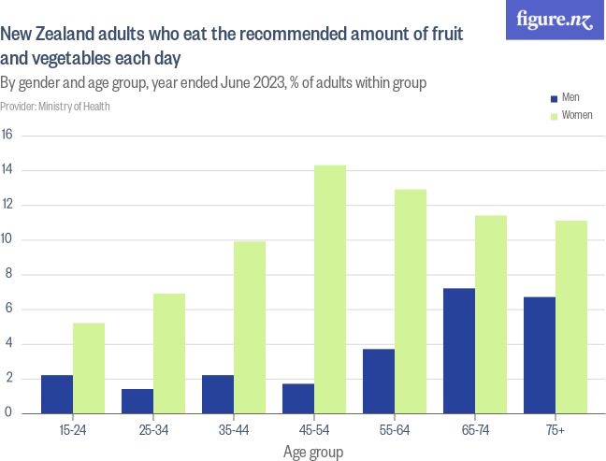

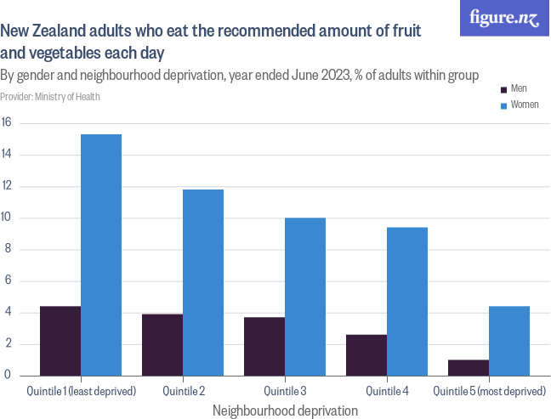

Using the information provided in the figures above and ideas explored in class, explain why fruit and vegetable consumption is a COMPLEX SOCIO-SCIENTIFIC issue.

Your answer should be 200-250 words.

**Fill in your answer here**

|  |
| --- |
| Format   Σ  |
|  |

|  |
| --- |
|  |
| Words: 0 |

4

Maximum marks: 4

1. Discuss why conversations in society about complex issues such as fruit and vegetable consumption are challenging. (4 Marks)

When framing your answer, you must refer to ideas from at least two different articles, websites or videos that were presented in Week 8

Your answer should be 200-250 words.

**Fill in your answer here**

|  |
| --- |
| Format   Σ  |
|  |
| Words: 0 |

Maximum marks: 4

**Section D contains SIX questions relating to:**

Disasters and approaches to Disaster Risk Reduction (DRR)

**Section D is worth a total of 10 marks.**

 **Answer ALL questions in this section ** **Questions 1-5 are worth 1 mark each**

 **Question 6 is a short answer question worth 5 marks**

**Section D questions were written by Anthony Gampell and you should draw from his lectures and studios in weeks 9 and 10 to answer this section.**

**Section D is worth a total of 10 marks. Answer ALL questions in this section.**

**There are FIVE Multi-choice/ True or False/ Multiple Response/ Drag and Drop styled questions worth 1 mark each and cover:**

 Definitions of Disaster;  Vulnerability

 Dominant strategies of DRR  Participation

 DRR

**There is also ONE long answer question worth five marks relating to top-down and bottom-up approaches to DRR. Your answer should follow a clear paragraph structure. Your answer should be around 300 words.**

1. A disaster is a natural phenomenon which is of potential danger for people and properties in a given area at a given period of time

**Select one alternative:**

 False

 True

Maximum marks: 1

1. People’s vulnerability in facing natural hazards reflects their marginal position within society:

They are marginalised because they live in hazardous places

Marginalised because they are member of minority groups

Marginalised because they are poor

Marginalised because their voice is disregarded by those with political power.

Maximum marks: 1

1. Dominant DRR Strategies:

**Select the FOUR characteristics that define dominant DRR strategies:**

 Understand local people understand local opportunities and challenges best

 Consider disasters local issues

 Believe people are resourceful/ have capacities

Focus on the interests of local people given they have the most interest in reducing the risk of disaster given their survival and well-being are at stake

 Focus on the extreme dimension of hazards

 Emphasise prevention and direct mitigation

 Strongly informed by science and technology

 Top-down, command and control, technocratic approach

Maximum marks: 1

1. Encouraging participatory DRR excludes support from the top-down.

**True or False?**

 False

 True

Maximum marks: 1

1. Insert the correct labels on the diagram

 Help

Bottom-up Initiatives

Local Knowledge

Inside Actors

Scientific Knowledge

Top-down Initiatives

Outside Actors

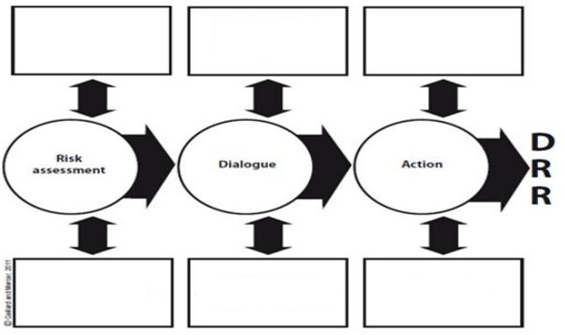

Maximum marks: 1

1. Demonstrate, using activities and example(s) explored in the disaster lectures and studios, why both top-down and bottom-up processes are required to achieve successful disaster risk reduction (DRR).

**Fill in your answer here**

|  |
| --- |
| Format   Σ  |
|  |
| Words: 0 |

Maximum marks: 5